Install Elastic Search Hadoop:

1. Launch and ssh to the instance to install elastic search stack.
2. Download 1.8 version of java:

**yum install java-1.8.0-openjdk\***

**/usr/sbin/alternatives --config java**

**vi /etc/sysconfig/elasticsearch**

**ES_JAVA_OPTS=-Xms15g**

**MAX_LOCKED_MEMORY=unlimited**

1. Install elastic search:

r**pm --import https://artifacts.elastic.co/GPG-KEY-elasticsearch**

**vi /etc/yum.repos.d/elasticsearch.repo**

**Copy:**

**[elasticsearch-5.x]**

**name=Elasticsearch repository for 5.x packages**

**baseurl=https://artifacts.elastic.co/packages/5.x/yum**

**gpgcheck=1**

**gpgkey=https://artifacts.elastic.co/GPG-KEY-elasticsearch**

**enabled=1**

**autorefresh=1**

**type=rpm-md**

**yum -y install elasticsearch**

1. Go to vi /etc/elasticsearch/elasticsearch.yml, open elasticsearch.yml and change the following configurations:

**cluster.name: Datalake**

**node.name: ${HOSTNAME}**

**bootstrap.memory_lock: true**

**network.host: [172.31.28.99, _local_]**

**discovery.zen.ping.unicast.hosts: ["ip-172-31-28-99.ec2.internal", "ip-172-31-18-.ec2.internal"]**

**bootstrap.memory_lock: true**

1. Configuration to complete bootstrap checks for production mode:

* **vi /etc/security/limits.conf**

**root soft nproc 2048**

**root hard nproc 2048**

**elasticsearch soft nproc 2048**

**elasticsearch hard nproc 2048**

**\* soft nproc 2048**

**\* hard nproc 2048**

* **vi /etc/elasticsearch/elasticsearch.yml**

**bootstrap.system_call_filter: false**

* **vi /etc/security/limits.conf**

**elasticsearch - nofile 65536**

**ulimit -n 65536**

* **vi /etc/sysconfig/elasticsearch**

**MAX_LOCKED_MEMORY=unlimited**

**ES_JAVA_OPTS="-Xms15g -Xmx15g" (Half of full memory)**

1. Start the elastic search:

* Use the chkconfig command to configure Elasticsearch to start automatically when the system boots up:

**chkconfig --add elasticsearch**

* Start elastic search:

**service elasticsearch start**

* Verify the status of elastic search:

**curl** <http://localhost:9200/_nodes/process?pretty>

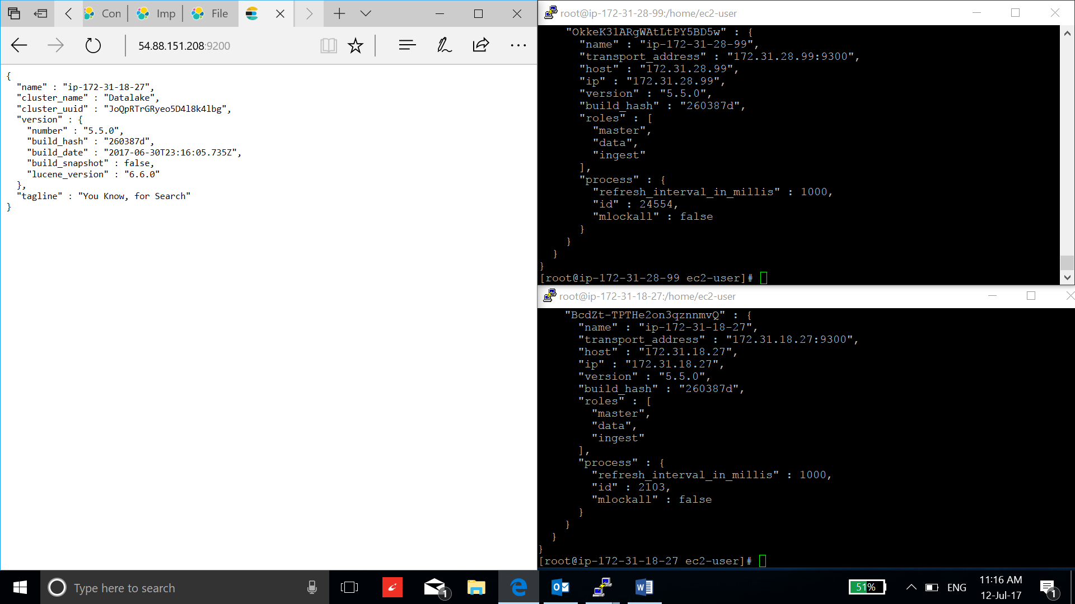

1. Install some plugins:

* Discovery plugin to discover ec2 nodes in a cluster:

**/usr/share/elasticsearch/bin/elasticsearch-plugin install discovery-ec2**

1. Install kibana:

**rpm --import** <https://artifacts.elastic.co/GPG-KEY-elasticsearch>

**vi /etc/yum.repos.d/kibana.repo**

**Copy:**

**[kibana-5.x]**

**name=Kibana repository for 5.x packages**

**baseurl=https://artifacts.elastic.co/packages/5.x/yum**

**gpgcheck=1**

**gpgkey=https://artifacts.elastic.co/GPG-KEY-elasticsearch**

**enabled=1**

**autorefresh=1**

**type=rpm-md**

**yum -y install kibana**

1. Configure kibana,

**vi /etc/kibana/kibana.yml**

**server.host: "<Private IP address>"**

**server.name: "Datalake-kibana"**

**elasticsearch.url: "http://54.88.151.208:9200"**